CS-360-H7351 Mobile Architect & Programming

4-4 Assignment: UI Design

Eric Wallace

Nov. 16, 2022

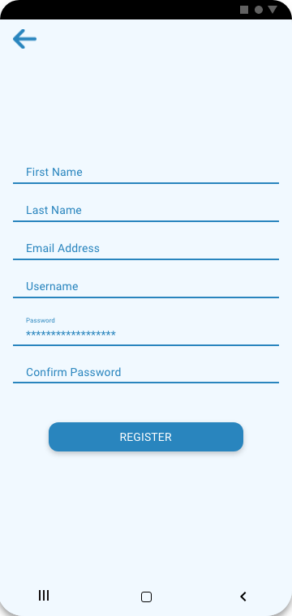

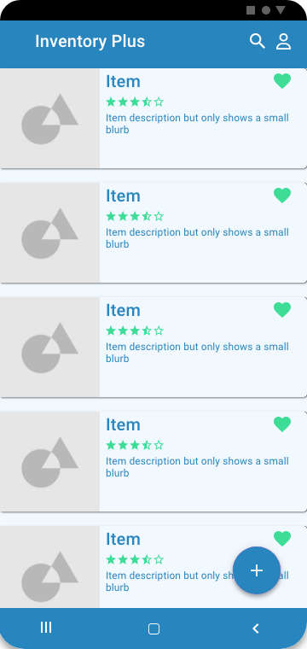

I have included three images of the proposed inventory application; each screen was designed in Adobe XD using the Material Design 2 template. The material design guidelines were followed by using the different components laid out in the template. The icons, text size, buttons, spacing were all designed by following the material design guidelines. The login screen is a very commonly used layout in the material design themed applications. Including the remember me checkbox was a feature I thought would be helpful to users to simplify their login to the application. The register button and forgot password link are standard on any login screen.

For the register screen, the EditText components adhere to the material design guidelines. The information for each of the textboxes is information I believe might be pertinent for an inventory application such as this. After entering the applicable information and clicking the register button the user’s information will be added to the database of users, an email would be sent asking users to verify their email address. The reason for the design is it adheres to material design guidelines, and it is my belief this is the easiest and most expedient way of having users register for the application.

The last screen included is the inventory screen or the main screen on the application. This page uses a repeatable card which includes an image, headline, description, a rating system, and a favorite button. All the components adhere to the material design guidelines and the template was used to layout the various components. The reason I used these designs over other designs is I believe this is the best way to show the inventory saved within the application database. This is one of the commonly used ways to display items to users. Also on this screen is a search button which will allow users to search for a particular item and there is also an avatar button which will allow them access their profile. I believe this is the best way of allowing users to access their profile.

My reasoning for using the layouts that I did is mostly because the layouts are commonly used for mobile applications. Other reasons I used the layout that I did is because I feel like it is the best way to serve the purpose in which the screen is created for. One feature that I think would be great to incorporate into the application is indicating if the username selected is unique or if it is already in use. That would require a function that would utilize an onChange event listener so that whenever the field changes. Another feature that might be good to include would be in the registration have a field that allows the user to select the type of inventory they will be using the application for and depending on the type of inventory might dictate what information is shown in the item card. I will have to look into how that functionality might work before actually naming it as a function or feature.